Урок в музее «Дедушкин чердак»
(for distance learning)
Museum website: https://www.museumcherdak.ru/
Virtual tour: https://clck.ru/RjjHf
Today you are going to have a lesson in the Grandfather's attic museum. You will complete different tasks. At the end of the lesson you will make your own bond certificate.
Task 1. Read the text about the laundry in the past and answer the questions.
In many ancient cultures people cleaned their clothes by pounding them on rocks or rubbing them with abrasive sands and washing the dirt away in streams or rivers. The Romans invented a crude soap, similar to lye, that contained ash and fat from sacrificed animals. In colonial times, the most common way of washing clothes was to boil them in a large pot or cauldron, then lay them on a flat board, and beat them with a paddle called dolly.
The metal washboard wasn't invented until about 1833. Before that, washboards were made entirely of wood, including the carved, ridged washing surface. As late as the Civil War, laundry was often a communal ritual, especially in places near rivers, springs, and other bodies of water, where the washing was done.
Answer the questions:
1) How did people clean their clothes in ancient times?
2) What did the Romans invent?
3) What is "dolly"?
4) When was the metal washboard invented?
Task 2. Look at the washing machines which are exposed in the museum. Find the Soviet washing machine «Волга-8Р». What type of wringing does it have?
- manual;
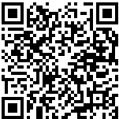
- automatic.
Task 3. The most successful hand-powered dishwasher was invented in 1887 by Josephine Cochrane. Choose the correct translation of her famous phrase.
a) If nobody else is going invent the dishwasher, then I'll do it myself.
b) If nobody else is going to invent the dishwasher, than I'll do it myself.
c) If nobody else is going to invent the dishwasher, then I'll do it myself.
Task 4. Study the table of the Morse alphabet. Using the Morse alphabet decrypt the following message. Work in groups.
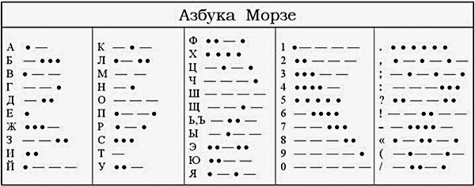

.-- . .-.. -.-. --- -- . - --- - .... . -- ..- ... . ..- -- --..--
Task 5. Using the table of the Morse alphabet fill in the questionnaire (age, date of birth and form write down in numbers). Work in pairs, check your partner's answer.
Name_____________________________________________________________
Age_______________________________________________________________
Date of birth________________________________________________________
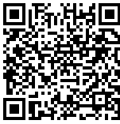
Form______________________________________________________________
Task 6. International maritime signal flags are various flags used to communicate with ships. The principal system of flags and associated codes is the International Code of Signals. Various navies have flag systems with additional flags and codes, and other flags are used in special uses, or have historical significance.
Study the table of International maritime signal flags and match the flags with their meanings.
Flag | Meaning of the signal
a) | 1) You should stop your vessel instantly
b) | 2) I am altering my course to the right
c) | 3) I am taking in or discharging or carrying dangerous goods
d) | 4) I have a diver down; keep well clear at slow speed
e) | 5) I am altering my course to the left
f) | 6) Man overboard

Task 7. Find the road sign in the museum. What does it mean?
a) Road narrows on right.
b) Road narrows on both sides.
c) Road narrows on left.
d) End of dual carriageway.
Task 8. Study the bond certificate of the Atlantic and St. Lawrence railroad company and answer the questions.
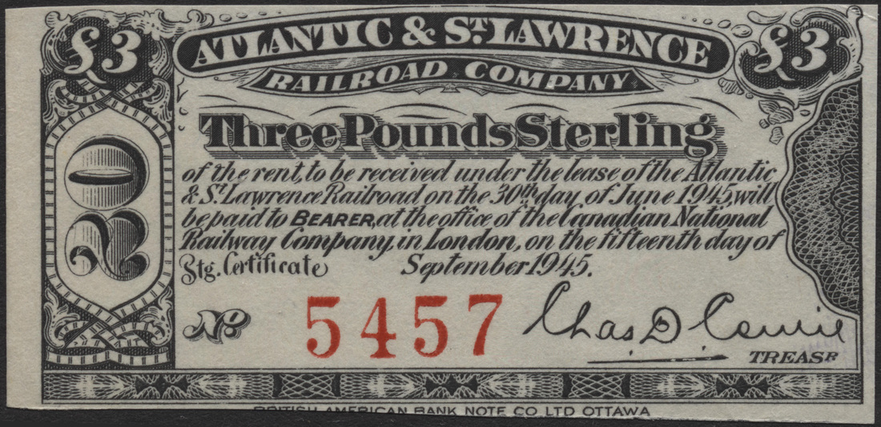
1) What is the value of this bond certificate?
__________________________________________________________________
2) When was the rent received?
__________________________________________________________________
3) Where should the bearer go to receive money? When?
__________________________________________________________________
Task 9. Pretend that you are the owner of the railroad in the 19th century. Make the bond certificate of your railroad. Write down the name of the railroad, the value of the bond certificate, etc. Use the information in task 8 as an example.

